Section I: Scenario Demographics

Scenario Title: | Digoxin Overdose
Date of Development: | 30/06/2015 (DD/MM/YYYY)
Target Learning Group: | Juniors (PGY 1 – 2) Seniors (PGY ≥ 3) All Groups

Section II: Scenario Developers

Scenario Developer(s): | Kyla Caners
Affiliations/Institution(s): | McMaster University
Contact E-mail (optional): | kcaners@gmail.com

Section III: Curriculum Integration

Learning Goals & Objectives
Educational Goal: | To push junior learners to the limits of their knowledge and understanding by presenting an overdose case with fairly complex management.
CRM Objectives: | Communicate effectively with team members during management of infrequent presentation.
Medical Objectives: | - Recognize potential for digoxin toxicity in elderly patient on digoxin.  - Recognize dysrhythmias associated with a digoxin overdose.  - Demonstrate an approach to digibind dosing for treatment of digoxin overdose.

Case Summary: Brief Summary of Case Progression and Major Events
90 year-old woman is brought to ED by her daughter because of confusion. She recently had a bought of vomiting and diarrhea and hasn’t been taking much PO since. Today, she is less responsive, seems confused, and is complaining of being dizzy. The team will be given a copy of the patient’s medication list, which will include digoxin. On arrival, the patient will be hypotensive and her rhythm will be bi-directional VT. Ideally, the team should give digibind. If they do not, they will receive blood work back with a high level to trigger administration.

References
Marx, J. A., Hockberger, R. S., Walls, R. M., & Adams, J. (2013). Rosen's emergency medicine: Concepts and clinical practice. St. Louis: Mosby.

Section IV: Scenario Script

A. Scenario Cast & Realism
Patient: | Computerized Mannequin |  |  |  |  | Realism:  Select most important dimension(s) |  |  | Conceptual
 | Mannequin |  |  |  |  |  |  |  | Physical
 | Standardized Patient |  |  |  |  |  |  |  | Emotional/Experiential
 | Hybrid |  |  |  |  |  |  |  | Other:
 | Task Trainer |  |  |  |  |  |  |  | N/A
Confederates | Brief Description of Role
None required.
B. Required Monitors
EKG Leads/Wires |  |  | Temperature Probe |  |  |  | Central Venous Line
NIBP Cuff |  |  | Defibrillator Pads |  |  |  | Capnography
Pulse Oximeter |  |  | Arterial Line |  |  |  | Other:
C. Required Equipment
Gloves |  |  | Nasal Prongs |  |  |  | Scalpel
Stethoscope |  |  | Venturi Mask |  |  |  | Tube Thoracostomy Kit
Defibrillator |  |  | Non-Rebreather Mask |  |  |  | Cricothyroidotomy Kit
IV Bags/Lines |  |  | Bag Valve Mask |  |  |  | Thoracotomy Kit
IV Push Medications |  |  | Laryngoscope |  |  |  | Central Line Kit
PO Tabs |  |  | Video Assisted Laryngoscope |  |  |  | Arterial Line Kit
Blood Products |  |  | ET Tubes |  |  |  | Other:
Intraosseous Set-up |  |  | LMA |  |  |  | Other:
D. Moulage
None required.

E. Approximate Timing
Set-Up: |  | 3 min |  | Scenario: | 12 min |  |  | Debriefing: |  | 20 min

Section V: Patient Data and Baseline State

A. Clinical Vignette: To Read Aloud at Beginning of Case
Mildred Funk is a 90 year old woman who is brought to the ED by her daughter because of confusion. She had some vomiting and diarrhea recently and hasn’t been eating or drinking much since. Today, she seems confused and keeps complaining that she’s dizzy to her daughter.
B. Patient Profile and History
Patient Name: Mildred Funk |  |  |  |  |  | Age: 90 |  |  |  |  |  |  |  | Weight: 60kg
Gender: M F |  |  |  |  |  | Code Status: Full.
Chief Complaint: “Dizzy”
History of Presenting Illness: Vomiting and diarrhea for the last few days. Now not taking much PO. Confused today, and complaining of being dizzy. No recent trauma. No travel. No sick contacts.
Past Medical History: |  | A fib |  |  |  |  | Medications: |  |  |  |  | Coumadin 4mg daily
 |  | CAD (stent x2 in 2009) |  |  |  |  |  |  |  |  |  | Metoprolol 25mg BID
 |  | HTN |  |  |  |  |  |  |  |  |  | Ramipril 5mg daily
 |  | Dyslipidemia |  |  |  |  |  |  |  |  |  | Rosuvastatin 10mg daily
 |  | Hypothyroidism |  |  |  |  |  |  |  |  |  | Levothyroxine 125mcg daily
 |  |  |  |  |  |  |  |  |  |  |  | Digoxin 0.0625 mg daily
Allergies: None.
Social History: Lives with her daughter. Non-smoker. No EtOH.
Review of Systems: |  | CNS: |  |  | Confused. Complains of being dizzy. No headache.
 |  | HEENT: |  |  | Nil.
 |  | CVS: |  |  | No CP. No palps.
 |  | RESP: |  |  | No SOB.
 |  | GI: |  |  | Nausea. Emesis this morning. Diarrhea last few days.
 |  | GU: |  |  | No LUTS.
 |  | MSK: |  |  | No sore joints. |  |  |  |  |  |  |  | INT: |  | No rashes.
C. Baseline Simulator State and Physical Exam
No Monitor Display |  |  |  | Monitor On, no data displayed |  |  |  |  |  |  | Monitor on Standard Display
HR: 160/min |  |  | BP: 90/55 |  |  |  |  | RR: 12/min |  |  |  |  |  |  | O₂SAT: 95%
Rhythm: Bigeminy |  |  | T: 36.5ºC |  |  |  |  | Glucose: 6.4 mmol/L |  |  |  |  |  |  | GCS: 13 (E4 V4 M5)
General Status: Confused and complaining of being dizzy.
CNS: | GCS 13 (confused). No FND.
HEENT: | No signs trauma.
CVS: | Tachycardic. No murmur.
RESP: | GAEB. No adventitious.
ABDO: | Soft, NT.
GU: | Nil.
MSK: | No signs trauma. |  |  |  |  |  |  |  | SKIN: | Nil.

Scenario States, Modifiers and Triggers
Patient State | Patient Status | Learner Actions, Modifiers & Triggers to Move to Next State
1. Baseline State  Rhythm: Bigeminy on monitor (ECG: bidirectional VT)  HR: 160  BP: 90/55  RR: 12/min  O₂SAT: 95%  T: 36.5ºC | Awake, but confused. Answers questions inappropriately with “dizzy.” | Learner Actions  - IV & monitors  - Attach defib pads  - ECG  - NS 1L bolus  - Cardiac/abdo/lactate/VBG and dig level  - Hx and Px  - Cap sugar: 6.4  - Call for digibind  - Call poison control | Modifiers  Changes to patient condition based on learner action  - NS bolus BP 85/45  - No dig level sent RN to prompt re: med list  - Rhythm not recognized: RN to prompt  Triggers  For progression to next state  - Cardioversion 2. Pulseless  - Digibind ordered 3. Blood Work Back  - 5 minutes 2. Pulseless
2. Pulseless  Rhythm VT  HR 180  BP ?/? | Pulseless and unresponsive. | Learner Actions  - Apply defib pads  - Shock VT  - Give digibind (10-20 vials)  - Call poison control  - Epinephrine q3min  - High quality CPR  - ± Amiodarone (if don’t recognize dig toxicity)  - ± Intubation | Modifiers  - Shock No change to rhythm  Triggers  - Digibind given 3. Blood Work Back  - 7 min 3. Blood Work Back
3. Blood Work Back  **Same vitals as previous state | State begins by saying “blood work is back” and giving results showing dig level 8 | Learner Actions  - Calculate digibind dose  # vials = [serum dig level (ng/mL) x weight in kg]/100 = [8x60]/100 = 4.8 = approximately 5 vials  **Because chronic toxicity, can assume dig level is steady state level  - Call poison control | Modifiers  Triggers  - Digibind given 4. Stabilization  - 12 min 4. Stabilization
4. Stabilization  Rhythm a fib  HR 120  BP 100/60 |  | Learner Actions  - Call medicine/ICU  - Repeat ECG  - Reassess patient | END CASE Consultants Arrive
Section VI: Scenario Progression

Section VII: Supporting Documents, Laboratory Results, & Multimedia

Laboratory Results
Na: 129 | K: 3.2 |  |  | Cl: 90 |  | HCO₃: 12 |  | BUN: 15 |  | Cr: 132 |  |  | Glu: 6.3
Ca: 2.1 |  |  | Mg: 0.91 |  |  |  | PO₄: 1.4 |  |  |  | Albumin: 30
VBG |  | pH: 7.30 |  |  | PCO₂: 24 |  | PO₂: 45 |  | HCO₃: 12 |  |  | Lactate: 2.6
WBC: 12 |  |  | Hg: 144 |  |  |  | Hct: |  |  |  | Plt: 350
Digoxin: 8 ng/mL |  |  | Troponin I: 25 |  |  |  | INR 2.5 |  |  |  | aPTT: 35
TB: 8 |  |  | AST: 30 |  |  |  | ALP: 40 |  |  |  | GGT: 24
Lipase: 20 |  |  |  |  |  |  | APAP: <20 |  |  |  | ASA: <0.36

Images (ECGs, CXRs, etc.)
ECG – Bidirectional VT  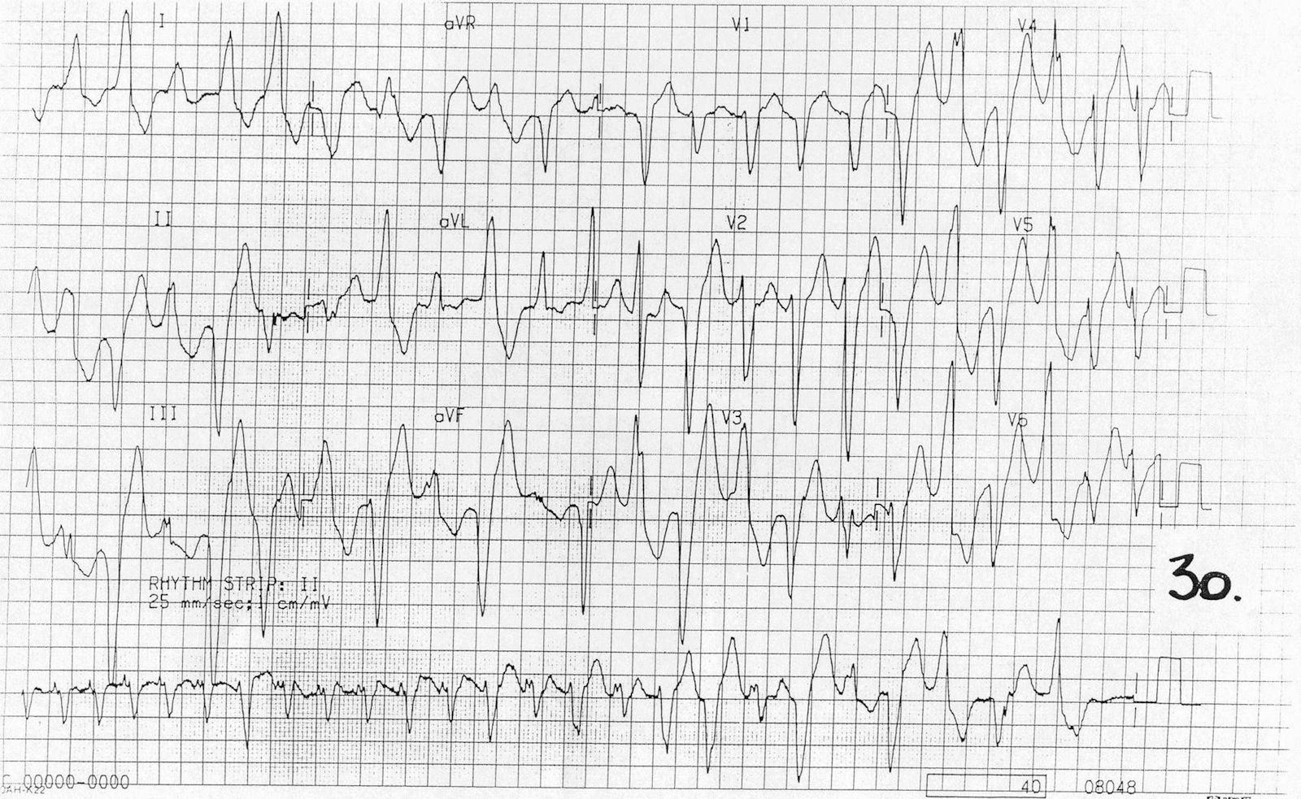  http://cdn.lifeinthefastlane.com/wp-content/uploads/2011/04/Bidirectional-VT.jpg | CXR – normal  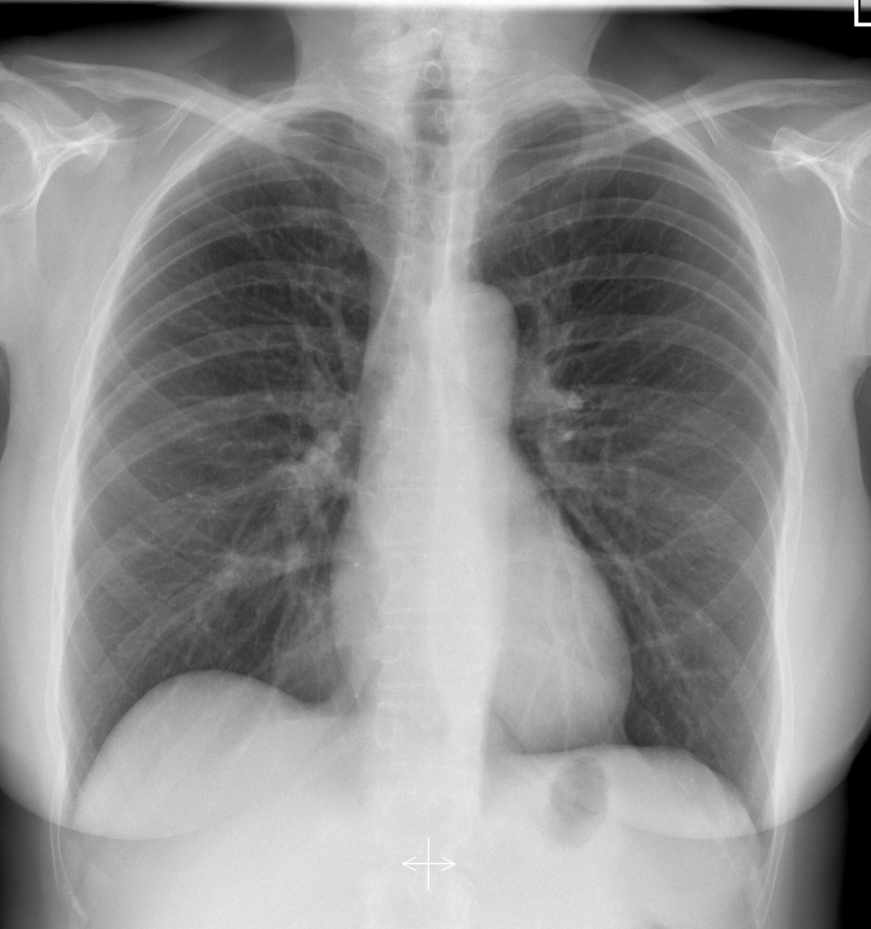  http://radiopaedia.org/articles/normal-position-of-diaphragms-on-chest-radiography
ECG – moderately rapid a fib

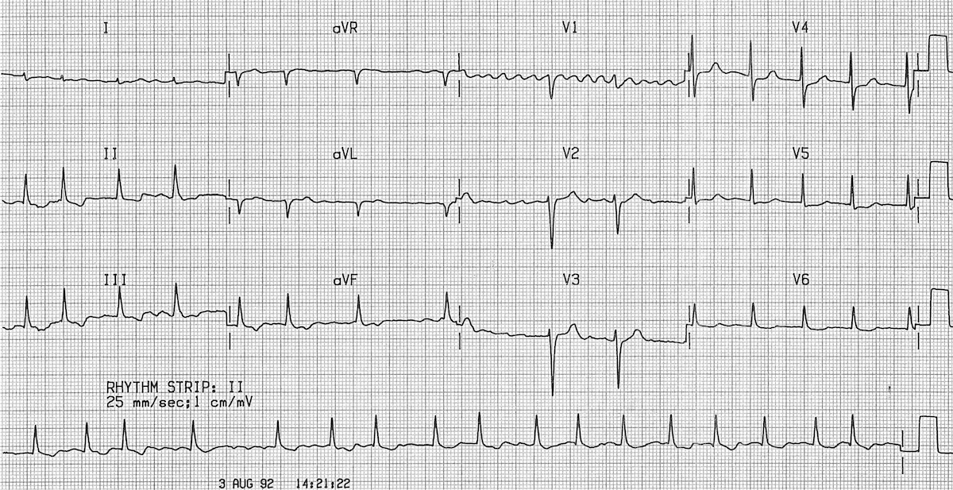

http://cdn.lifeinthefastlane.com/wp-content/uploads/2011/08/af1.jpg

Section VIII: Debriefing Guide

General Debriefing Plan
Individual | Group |  | With Video | Without Video
Objectives
Educational Goal: |  | To push junior learners to the limits of their knowledge and understanding by presenting an overdose case with fairly complex management.
CRM Objectives: |  | Communicate effectively with team members during management of infrequent presentation.
Medical Objectives: |  | - Recognize potential for digoxin toxicity in elderly patient on digoxin.  - Recognize dysrhythmias associated with a digoxin overdose.  - Demonstrate an approach to digibind dosing for treatment of digoxin overdose.
Sample Questions for Debriefing
- When did you first consider digoxin toxicity as a possible cause of this presentation?
- What clues were there in this case that pointed toward digoxin toxicity?
- Did your team feel comfortable calculating a digibind dose? How did your team dynamics feel with this uncommon medication to administer?
- What are the indications for digibind? Did this patient meet them?
- What are other important differential diagnoses to consider in this elderly patient with altered LOC?
Key Moments
Recognition of possible digoxin toxicity
Determination of digibind dose

